PRACTICAL EXAMINATION

WEB TECHNOLOGY

SNEHA GUPTA

2021UCA1859

20/12/2022

XML:

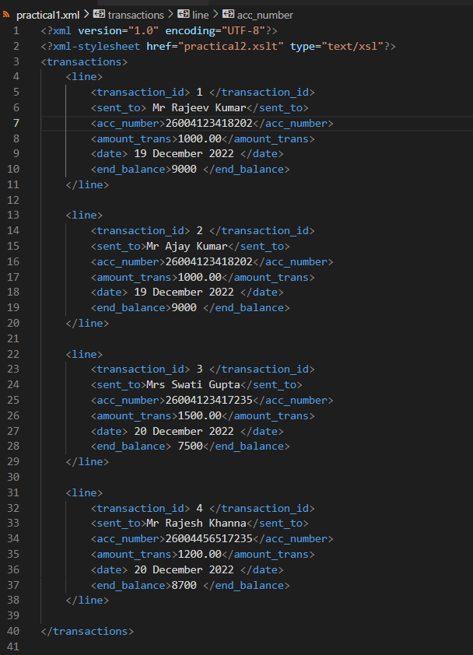

XSLT:

